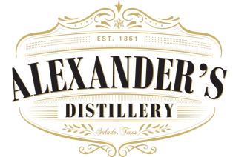

Ireland Themed Dinner
In honor of St. Patrick’s Day
March 14, 2019

First Course

Creamy potato caraway seed soup

Shannon Irish Red Ale

Second Course

House salad with cherry tomatoes, shaved carrots tossed in a sesame seed vinaigrette

“old Thyme Sour”

Entrée Course

Corn Beef and Cabbage with house made corned beef, chard Guinness cabbage and smashed redskin potatoes

“Black & Blue”

Dessert Course

‘Irish Car bomb cake’

Chocolate Guinness stout cake, with Irish cream frosting and a whiskey caramel reduction

“Irish Coffee”

$39.95 per guest
Substitutions are politely declined
Gratuity is not included, please take care of your servers

